Math Circle Problem Set 2. Name:

Problem 2.1: Horse, Cow, Dog, and Cat went to a theater and sat in a row of four seats.

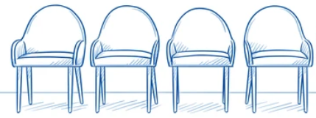
#1 #2 #3 #4

Here is what I heard afterwards:
- Cow and Cat took the seats on the ends.
- Dog’s seat number and Cow’s seat number were bigger than Horse’s seat number.

Write the name of each animal above the chair it sat in.

Problem 2.2: Little Squirrel is having a birthday party today. Squirrel’s six friends Owl, Deer, Rabbit, Lynx, Mouse, and Fox came over to celebrate.
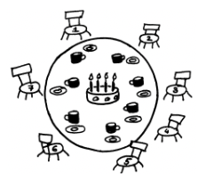 | 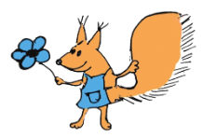

Here is what I heard afterwards:
- Owl’s neighbors were Fox and Lynx.
- Squirrel took chair number four near Rabbit.
- Mouse was scared and refused to sit next to any predator.
- There were two guests seated in between Owl and Squirrel.
- Lynx chose chair number two.

Write the name of each animal above the chair it sat in.
Problem 2.3: Cat and Dog are playing a game where there are 20 stones in a pile. They take turns taking stones from the pile - on your turn you can take 1, 2, or 3 stones. The winner isn’t who ends up with the MOST stones - it’s who ends up taking the LAST stone from the pile.

Play some games with the other students and try to figure out how to win. Does the first player always have a strategy that can win? Or the second player?

What if there are a different number of stones than 20 initially?

Problem 2.4: Put the numbers 1, 2, 3, 4, 5, and 6 in the circles of the triangle so that along each side of the triangle, if you add the numbers along that side, you get the same total.

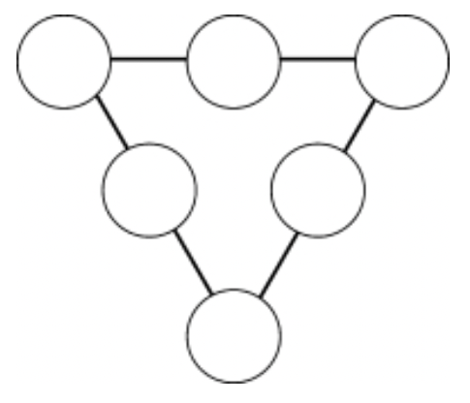

Problem 2.5: Tree problem (to be explained in class):
